FUNCTIONALITY TEST DOCUMENT |  | Module Name |  | WEBSITE ONLINE BOOKING MODULE
Test Cycle No. |  | Function Name |  | WEBSITE APPOINTMENT REQUEST
 |  | User/Access Type |  | Patient
Date Tested |  | Type of System |  | Web Application
Pre-Conditions | The patient must have access to the NgitiFy website and the online appointment booking form must be available.
Action Description | Submit an appointment request through the website.
Verification Steps | Enter the required appointment details, complete the required consent and CAPTCHA verification, submit the request, and verify the result.
Test Scenario | Expected Results |  | Actual Results |  | Remarks
1 | The appointment request must be submitted successfully. |  | 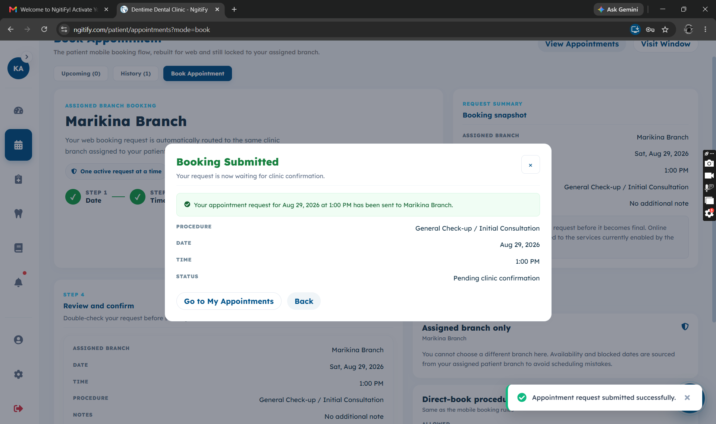

FUNCTIONALITY TEST DOCUMENT |  | Module Name |  | REGISTRATION MODULE
Test Cycle No. |  | Function Name |  | PATIENT PRE-REGISTRATION
 |  | User/Access Type |  | Patient
Date Tested |  | Type of System |  | Web Application
Pre-Conditions | The patient has successfully submitted an online appointment request and the pre-registration form is accessible.
Action Description | Complete and submit the patient pre-registration form.
Verification Steps | Enter the required patient information, submit the pre-registration form, and verify that the registration details are successfully processed.
Test Scenario | Expected Results |  | Actual Results |  | Remarks
1 | Must be able to complete and submit the pre-registration form successfully. |  | 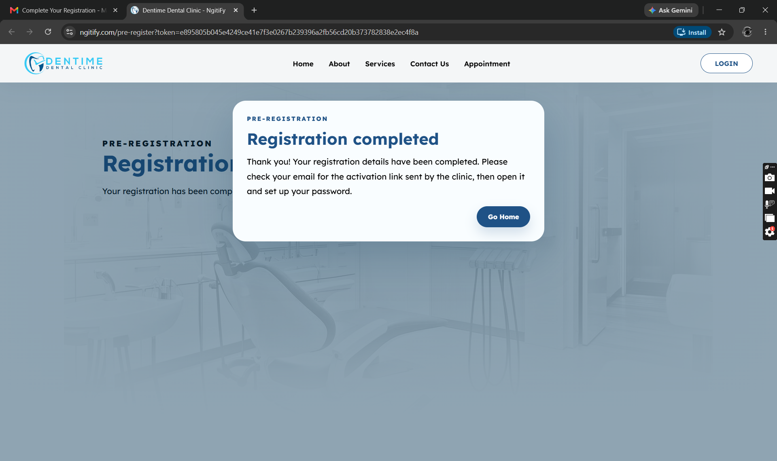

FUNCTIONALITY TEST DOCUMENT |  | Module Name |  | REGISTRATION MODULE
Test Cycle No. |  | Function Name |  | SET-UP PASSWORD
 |  | User/Access Type |  | Patient
Date Tested |  | Type of System |  | Web Application
Pre-Conditions | The patient must be successfully registered and have access to the account activation link.
Action Description | Set up the patient account password.
Verification Steps | Enter and confirm a valid password, submit the password setup, and verify that the account is successfully activated.
Test Scenario | Expected Results |  | Actual Results |  | Remarks
1 | Must be able to set up the account password successfully. |  | 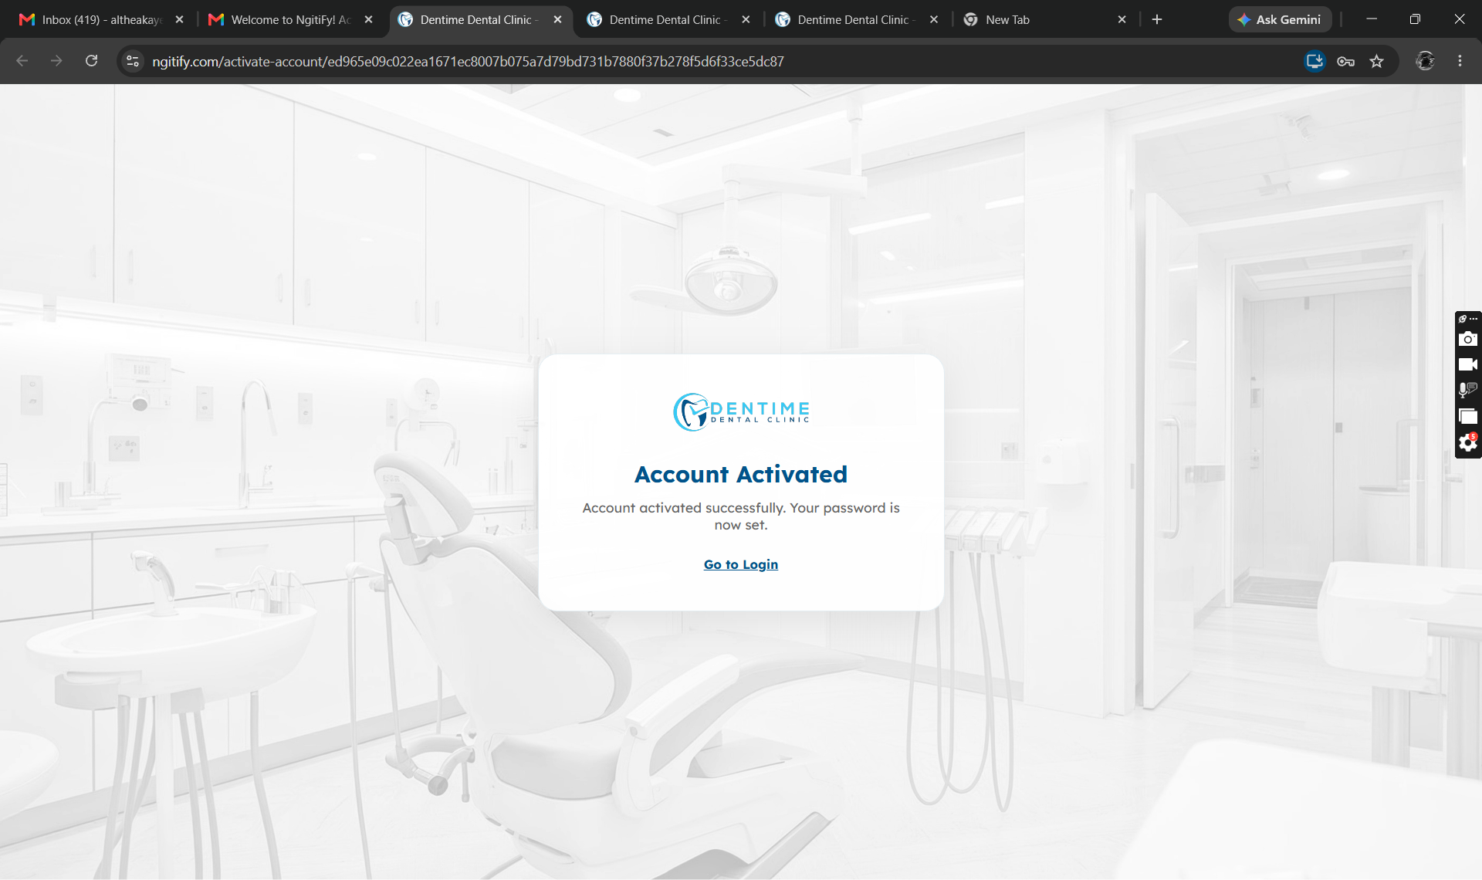

FUNCTIONALITY TEST DOCUMENT |  | Module Name |  | LOGIN MODULE
Test Cycle No. |  | Function Name |  | LOGIN
 |  | User/Access Type |  | Patient
Date Tested |  | Type of System |  | Web Application
Pre-Conditions | The patient must have a registered and activated account.
Action Description | Log in to the system using the patient account credentials.
Verification Steps | Enter valid login credentials, click the Login button, and verify that the patient is successfully logged in and redirected to the appropriate dashboard.
Test Scenario | Expected Results |  | Actual Results |  | Remarks
1 | Must be able to set up the account password successfully. |  | 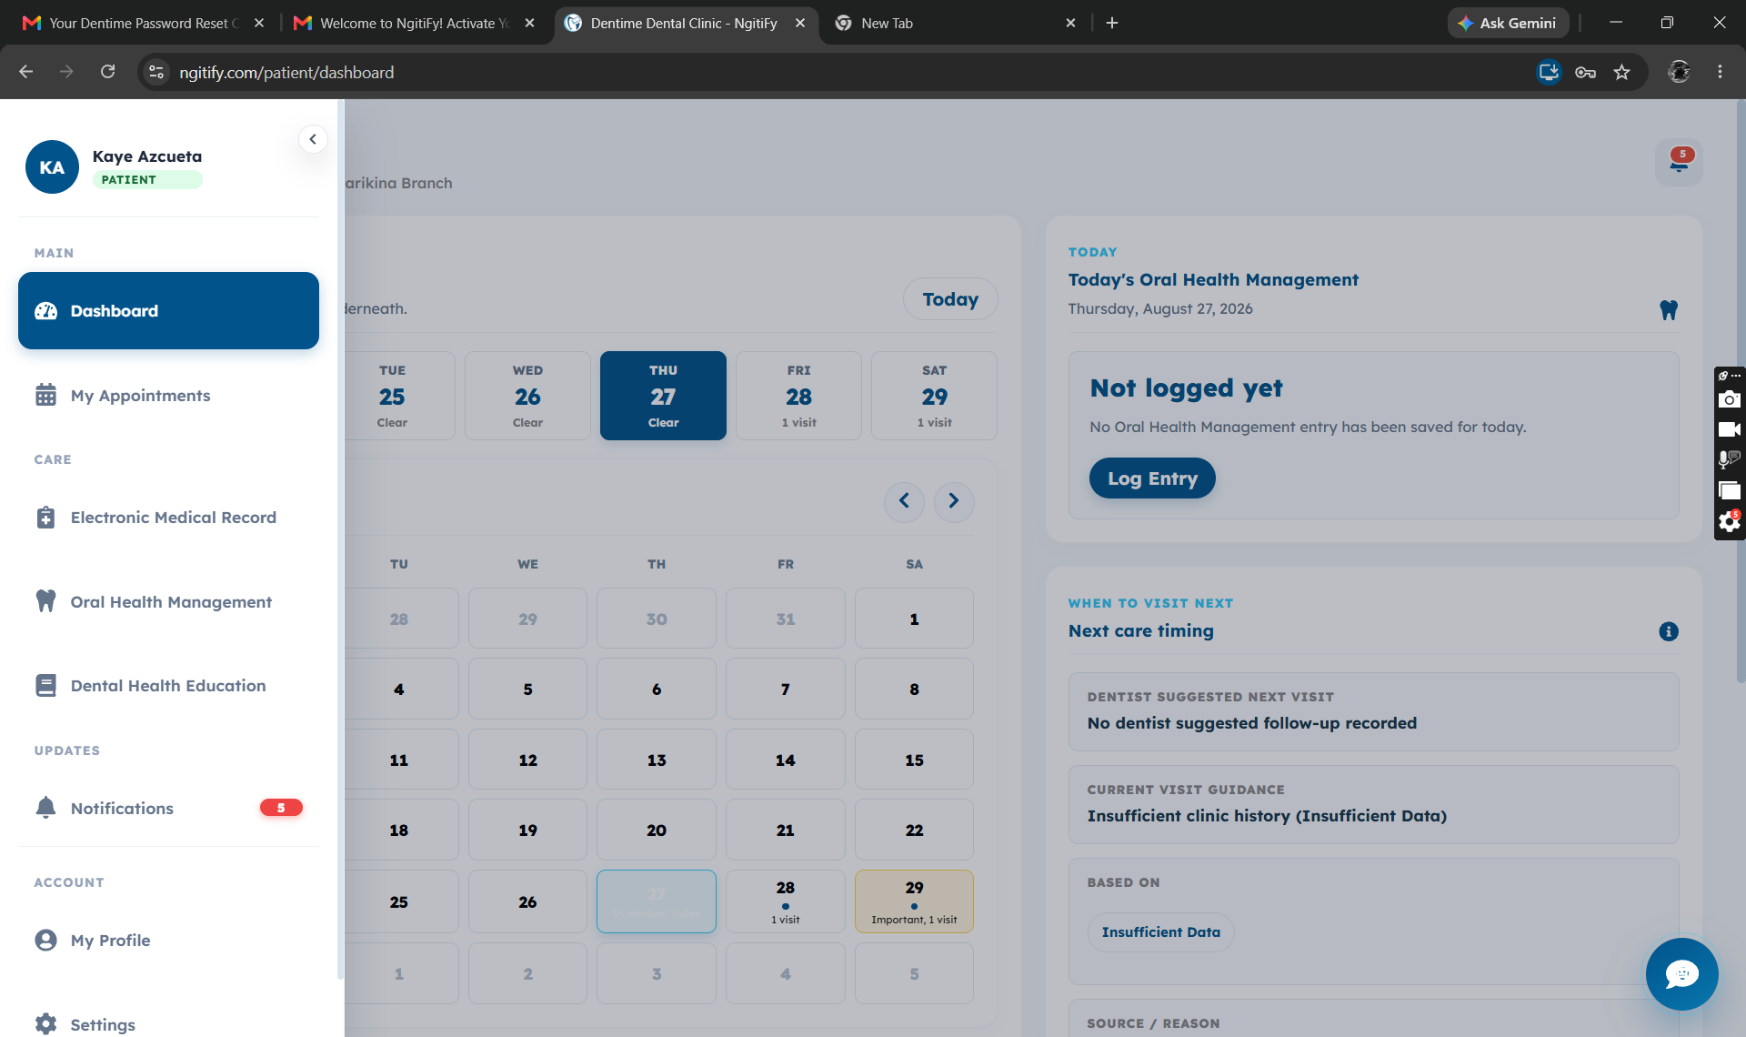

FUNCTIONALITY TEST DOCUMENT |  | Module Name |  | LOGIN MODULE
Test Cycle No. |  | Function Name |  | FORGOT PASSWORD
 |  | User/Access Type |  | Patient
Date Tested |  | Type of System |  | Web Application
Pre-Conditions | The patient must have a registered account and access to the login page.
Action Description | Request a password reset for the patient account.
Verification Steps | Click Forgot Password, enter the registered email address, submit the request, and verify that the password reset process is initiated.
Test Scenario | Expected Results |  | Actual Results |  | Remarks
1 | Must be able to request a password reset successfully. |  | 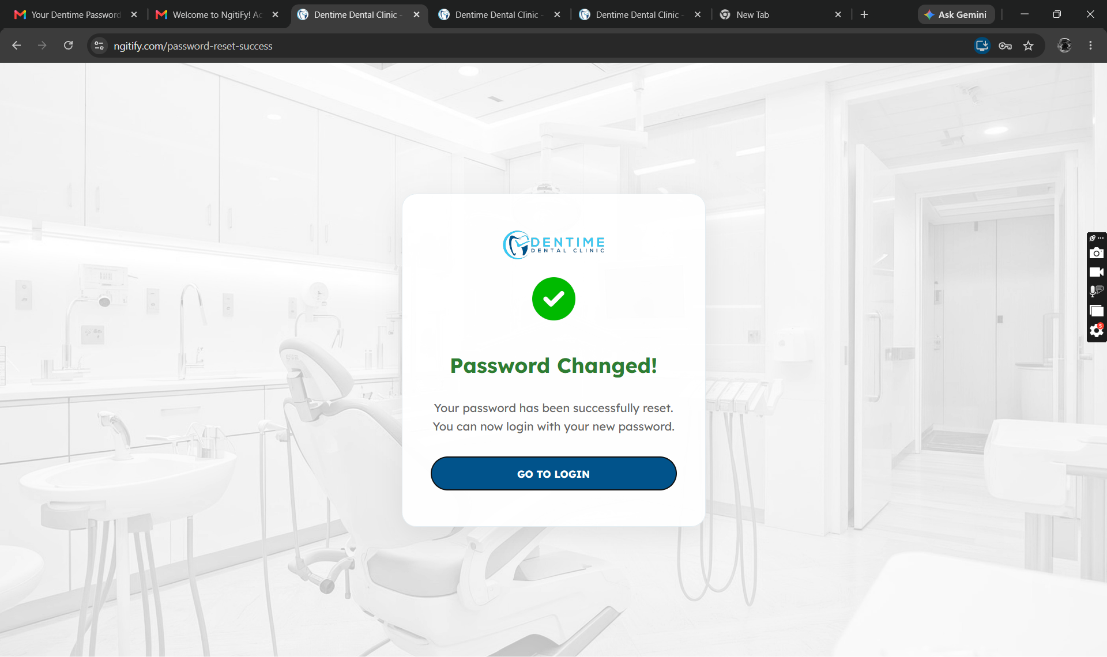

FUNCTIONALITY TEST DOCUMENT |  | Module Name |  | LOGIN MODULE
Test Cycle No. |  | Function Name |  | FORGOT PASSWORD - OTP
 |  | User/Access Type |  | Patient
Date Tested |  | Type of System |  | Web Application
Pre-Conditions | Enter email in the Forgot Password page.
Action Description | Validate the OTP.
Verification Steps | Verify that the correct OTP redirects the user to the Reset Password page and an incorrect OTP displays an error message.
Test Scenario | Expected Results |  | Actual Results |  | Remarks
1 | The New Password page must display after entering the correct OTP. |  | 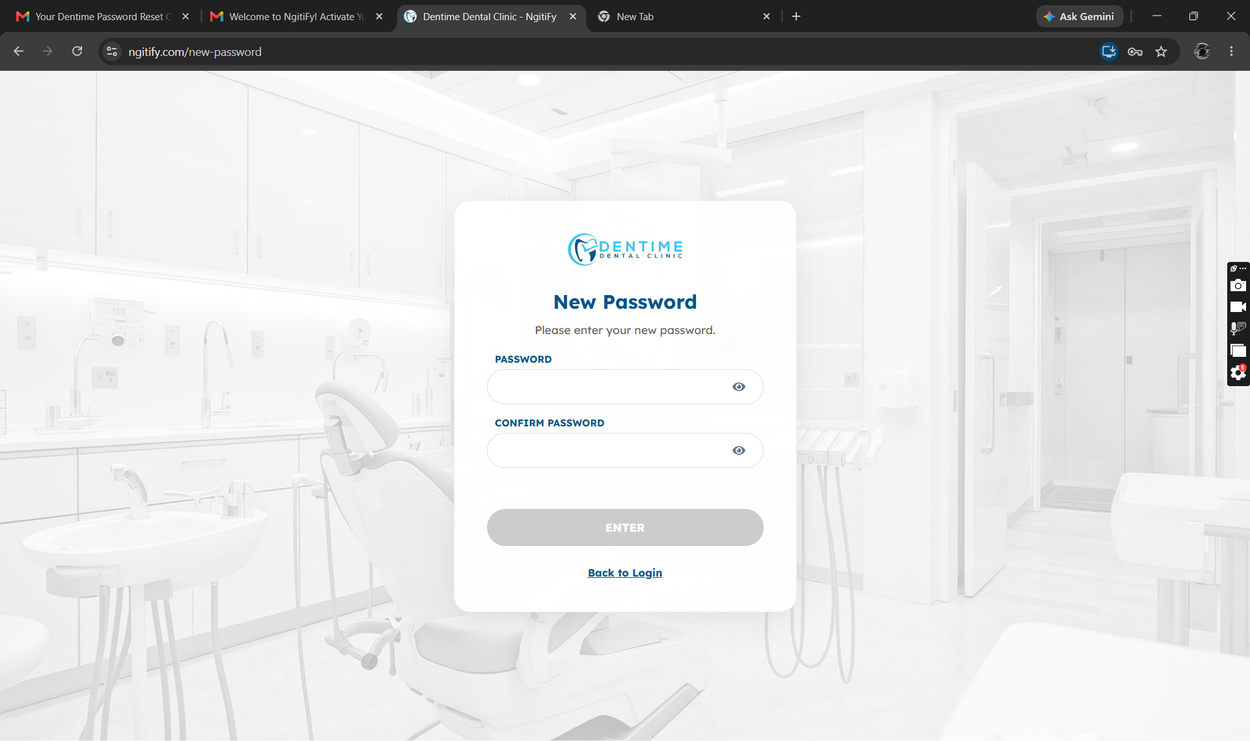
2 | The message must display “Invalid or expired OTP” after entering an incorrect OTP. |  | 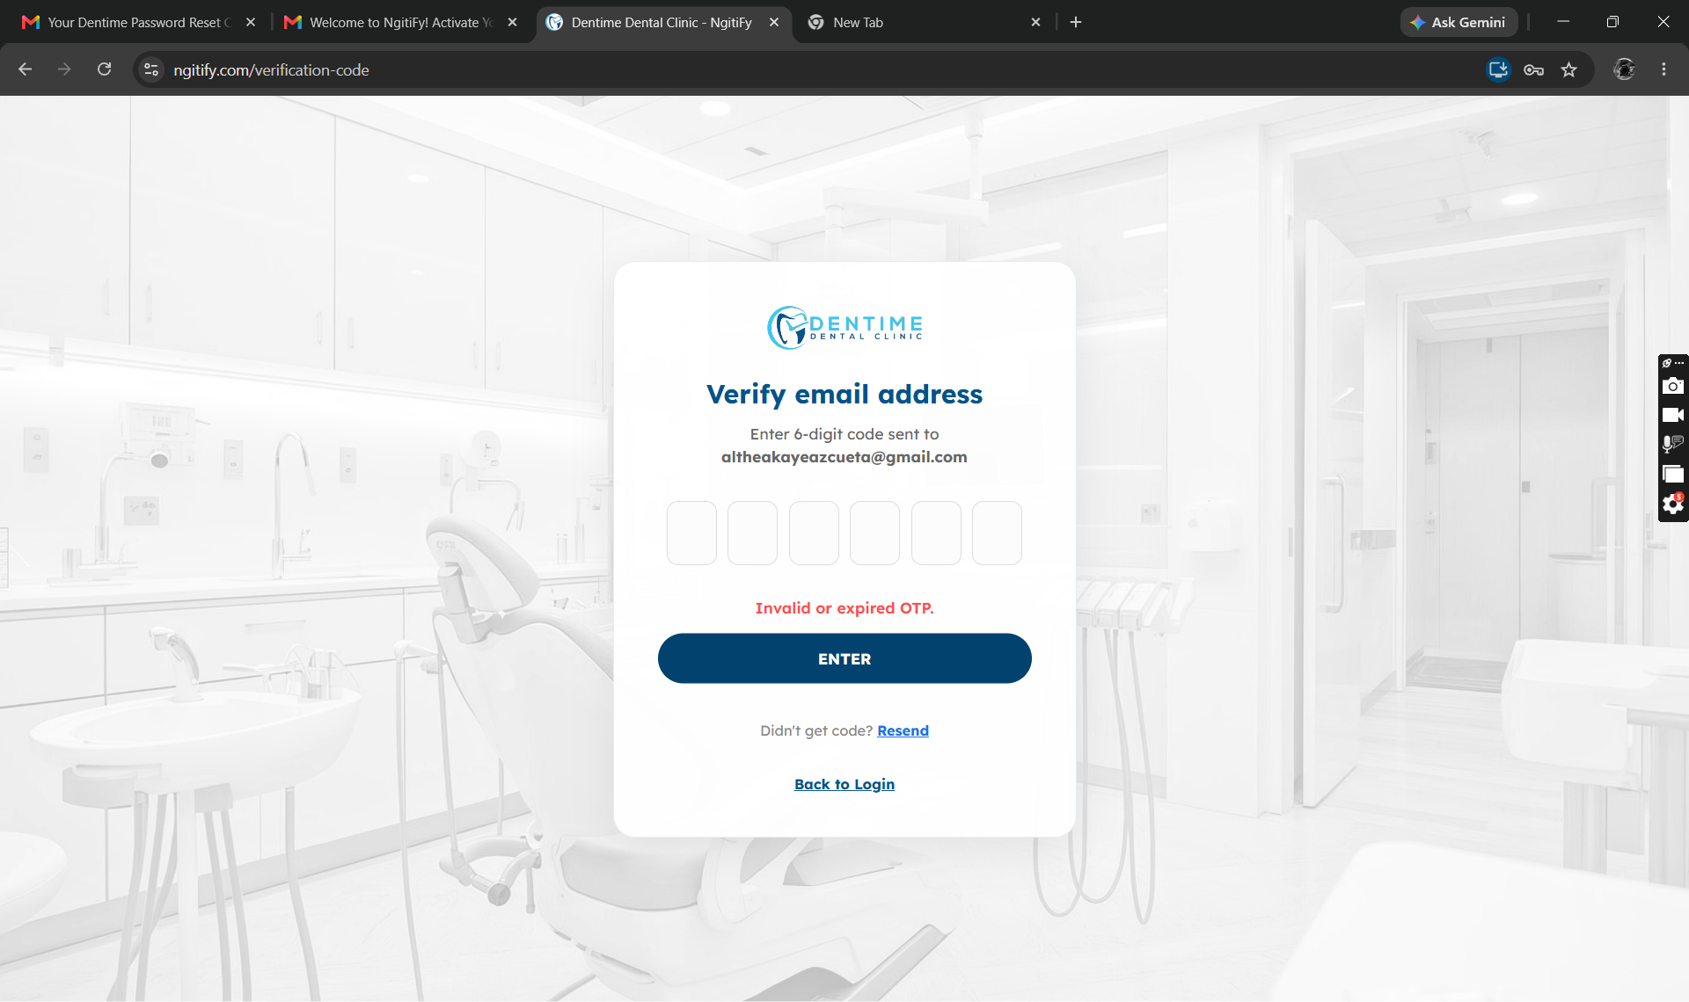
3 | The message must display “New code sent” and the resend countdown must restart |  | 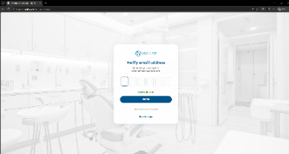

FUNCTIONALITY TEST DOCUMENT |  | Module Name |  | LOGIN MODULE
Test Cycle No. |  | Function Name |  | RESET PASSWORD
 |  | User/Access Type |  | Patient
Date Tested |  | Type of System |  | Web Application
Pre-Conditions | Enter the valid OTP in the OTP page.
Action Description | Validate the new and confirm password.
Verification Steps | Verify that the password is successfully reset and the appropriate validation message is displayed.
Test Scenario | Expected Results |  | Actual Results |  | Remarks
1 | The password must be successfully reset and the login page must display. |  | 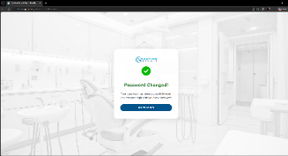

FUNCTIONALITY TEST DOCUMENT |  | Module Name |  | ACCOUNT SETTINGS MODULE
Test Cycle No. |  | Function Name |  | EDIT PROFILE
 |  | User/Access Type |  | Patient
Date Tested |  | Type of System |  | Web Application
Pre-Conditions | Log in as a Patient, click My Profile from the sidebar, then select Edit Profile.
Action Description | Update and validate the patient's profile details.
Verification Steps | Check whether the updated profile information is saved successfully and whether the proper validation messages appear for incomplete or invalid entries.
Test Scenario | Expected Results |  | Actual Results |  | Remarks
1 | A confirmation message must appear, and the patient's updated profile information must be saved successfully. |  | 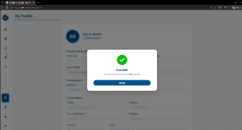

FUNCTIONALITY TEST DOCUMENT |  | Module Name |  | ACCOUNT SETTINGS MODULE
Test Cycle No. |  | Function Name |  | CHANGE PASSWORD
 |  | User/Access Type |  | Patient
Date Tested |  | Type of System |  | Web Application
Pre-Conditions | Log in, click Settings from the sidebar, and click Account Security.
Action Description | Validate the current password, new password, and confirm new password.
Verification Steps | Verify that the password is successfully updated when valid credentials are entered and that appropriate validation messages are displayed for invalid entries.
Test Scenario | Expected Results |  | Actual Results |  | Remarks
1 | The password must be updated successfully, and a confirmation message must display. |  | 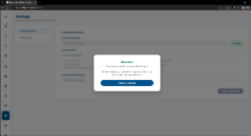

FUNCTIONALITY TEST DOCUMENT |  | Module Name |  | ACCOUNT SETTINGS MODULE
Test Cycle No. |  | Function Name |  | CHANGE EMAIL
 |  | User/Access Type |  | Patient
Date Tested |  | Type of System |  | Web Application
Pre-Conditions | Log in, click My Profile from the sidebar, and click Change Email.
Action Description | Validate the new email address and current password.
Verification Steps | Verify that the system validates the entered email address and password before processing the email change request.
Test Scenario | Expected Results |  | Actual Results |  | Remarks
1 | A verification request must be sent successfully after entering a valid email address and correct password. |  | 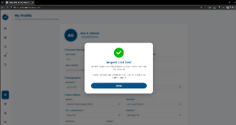

FUNCTIONALITY TEST DOCUMENT |  | Module Name |  | ACCOUNT SETTINGS MODULE
Test Cycle No. |  | Function Name |  | NOTIFICATIONS
 |  | User/Access Type |  | Patient
Date Tested |  | Type of System |  | Web Application
Pre-Conditions | User is logged in and Notifications page is accessible
Action Description | Update notification preferences
Verification Steps | Enable or disable notification preferences and save changes
Test Scenario | Expected Results |  | Actual Results |  | Remarks
1 | Notification preferences are saved successfully |  | 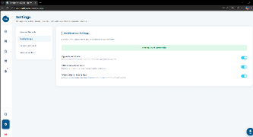
2 | Saved preferences remain after reopening the page |  | 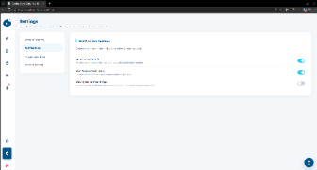

FUNCTIONALITY TEST DOCUMENT |  | Module Name |  | USER ACCOUNTS MANAGEMENT MODULE
Test Cycle No. |  | Function Name |  | SEARCH/FILTER STAFF
 |  | User/Access Type |  | Admin
Date Tested |  | Type of System |  | Web Application
Pre-Conditions | Login, click Manage Staffs from the sidebar.
Action Description | Search and filter staff records.
Verification Steps | Enter search criteria and verify the displayed staff results.
Test Scenario | Expected Results |  | Actual Results |  | Remarks
1 | Matching staff records are displayed |  | 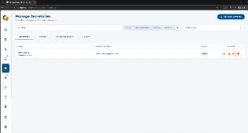

FUNCTIONALITY TEST DOCUMENT |  | Module Name |  | USER ACCOUNTS MANAGEMENT MODULE
Test Cycle No. |  | Function Name |  | ADD NEW STAFF
 |  | User/Access Type |  | Admin
Date Tested |  | Type of System |  | Web Application
Pre-Conditions | Login, click Manage Staffs from the sidebar, then click Add New.
Action Description | Add a new staff account.
Verification Steps | Enter the required staff information and submit the form.
Test Scenario | Expected Results |  | Actual Results |  | Remarks
1 | New staff account is added successfully |  | 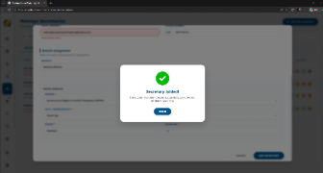

FUNCTIONALITY TEST DOCUMENT |  | Module Name
Test Cycle No. |  | Function Name
 |  | User/Access Type
Date Tested |  | Type of System |  | Web Application
Pre-Conditions
Action Description
Verification Steps
Test Scenario | Expected Results |  | Actual Results |  | Remarks

FUNCTIONALITY TEST DOCUMENT |  | Module Name
Test Cycle No. |  | Function Name
 |  | User/Access Type
Date Tested |  | Type of System |  | Web Application
Pre-Conditions
Action Description
Verification Steps
Test Scenario | Expected Results |  | Actual Results |  | Remarks

FUNCTIONALITY TEST DOCUMENT |  | Module Name
Test Cycle No. |  | Function Name
 |  | User/Access Type
Date Tested |  | Type of System |  | Web Application
Pre-Conditions
Action Description
Verification Steps
Test Scenario | Expected Results |  | Actual Results |  | Remarks

FUNCTIONALITY TEST DOCUMENT |  | Module Name
Test Cycle No. |  | Function Name
 |  | User/Access Type
Date Tested |  | Type of System |  | Web Application
Pre-Conditions
Action Description
Verification Steps
Test Scenario | Expected Results |  | Actual Results |  | Remarks

FUNCTIONALITY TEST DOCUMENT |  | Module Name
Test Cycle No. |  | Function Name
 |  | User/Access Type
Date Tested |  | Type of System |  | Web Application
Pre-Conditions
Action Description
Verification Steps
Test Scenario | Expected Results |  | Actual Results |  | Remarks

